|  |  |  |
| --- | --- | --- |
| VILNIAUS KOLEGIJA  UNIVERSITY OF APPLIED SCIENCES  FACULTY OF ELECTRONICS AND INFORMATICS  DEPARTMENT OF SOFTWARE ENGINEERING  https://screenshotscdn.firefoxusercontent.com/images/eaf3f7f3-2952-4801-af5c-4f20e8ae8b88.png | | |
|  | | |
| **WEB SERVICES ANALYSIS OF CONTENT MANAGEMENT SYSTEM** | | |
| INDIVIDUAL WORK  6531BX028 PI18E | | |
| STUDENT | (SIGNATURE) | EDITA KOMAROVA |
| LECTURER | 2020-04 | AIRINA SAVICKAITĖ |
|  | (SIGNATURE) |  |
|  | 2020-04 |  |
| 2020 | | |

# INTRODUCTION

Content management system is essential part of web services, but what is exactly content management system and how does it’s helps it’s users? What kind features does the content management system has? How the content management is structures? What are real example of the Content management systems?

# PURPOSE

The purpose of this essay is to explain what is the content management system and why it’s necessary for people that are using it. Finding out what kind of features does the content management system have. It’s structure and what are the real examples of the content management systems.

Table of Contents

INTRODUCTION 2

PURPOSE 3

1.WHAT IS CONTENT MANAGEMENT SYSTEM? 5

2.FEATURES OF CMS 6

3.HOW DOES THE CONTENT MANAGEMENT SYSTEM WORKS? 7

4.WHAT MAKES UP A CONTENT MANAGEMENT SYSTEM? 9

5.POPULAR CMS SYSTEMS 10

5.1.Wordpress 10

5.2.Joomla 10

5.3.Drupal 10

CONCLUSION 12

SOURCES 13

Table of figures

Figure 1- Post editor of WordPress 7

Figure 2- WordPress Media library 8

# 1.WHAT IS CONTENT MANAGEMENT SYSTEM?

Content management system (often abbreviated as CMS) – is a software that helps users create, manage, and modify content on a website without the need for specialized technical knowledge.

In simpler language, a content management system is a tool that helps you build a website without needing to write all the code from scratch (or even know how to code at all)[1].Which is very beneficial for a person that couldn’t afford hiring the programmer who can build a very functional website.

The content management system helps user to create their own web pages, store images, and other functions. The content management system handles all that basic infrastructure stuff for you so that you can focus on more forward-facing parts of your website [1].

Other than websites, there is also a features document management that can be found in amongst other features of content management system.

# 2.FEATURES OF CMS

Features can vary amongst the various CMS offerings, but the main functions are often considered to be indexing, search and retrieval, format management, revision control and publishing.

Natural ordering, search and recovery highlights file all information for simple access through inquiry works and permit clients to look by traits, for example, distribution dates, watchwords or creator.

Format management facilitates turn scanned paper documents and legacy electronic documents into HTML or PDF documents [2].

Revision features allow content to be updated and modified after initial publication. Reviewing control also tracks any changes made to files by the authors.

Publishing functionality allows individuals to use a template or a set of templates approved by the organization, as well as wizards and other tools to create or edit content.

A CMS may also provide tools for one-to-one marketing. One-to-one marketing is the ability of a website to tailor its content and advertising to a user's specific characteristics using information provided by the user or gathered by the site -- for instance, a particular user's page sequence pattern. For example, if the user visited a search engine and searched for digital camera, the advertising banners would feature businesses that sell digital cameras instead of businesses that sell garden products.

Other popular features of CMSes include: SEO-friendly URLs. Integrated and online help, including discussion boards. Group-based permission systems. Full template support and customizable templates. Easy wizard-based install and versioning procedures. Admin panel with various language support. Content hierarchy with unlimited depth and width. Minimal server requirements .Integrated file managers. Integrated audit logs.

# 3.HOW DOES THE CONTENT MANAGEMENT SYSTEM WORKS?

To give you an idea of how a content management system works, we’re going to take a whirlwind tour of the WordPress interface (WordPress is a good example of a content management system).

Let’s start with creating a piece of content. Without a content management system, you’d need to write a static HTML file and upload it to your server (sounds complicated, right?).

With a content management system like WordPress, you can just write your content in an interface that looks a good bit like Microsoft Word [Figure 1]:

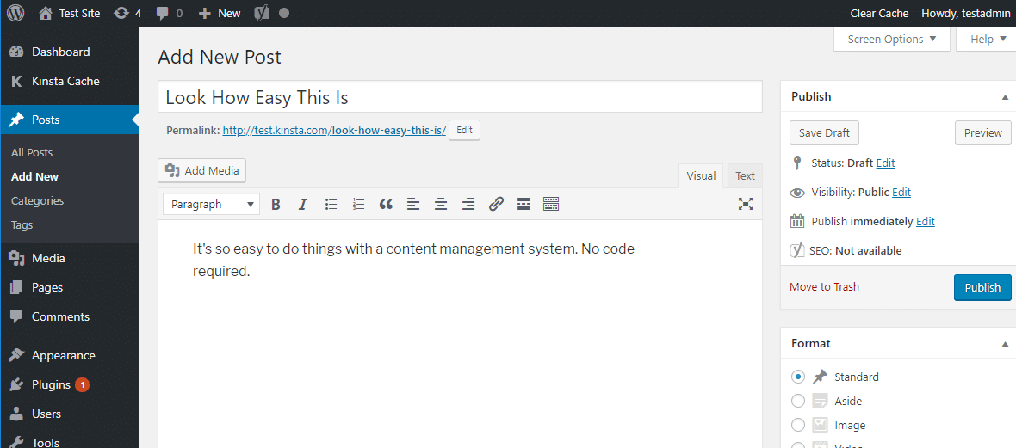

Figure 1- Post editor of WordPress

Similarly, to upload and manage media, like images, you can just browse the media library instead of needing to actually interact with your web server directly [Figure 2]:

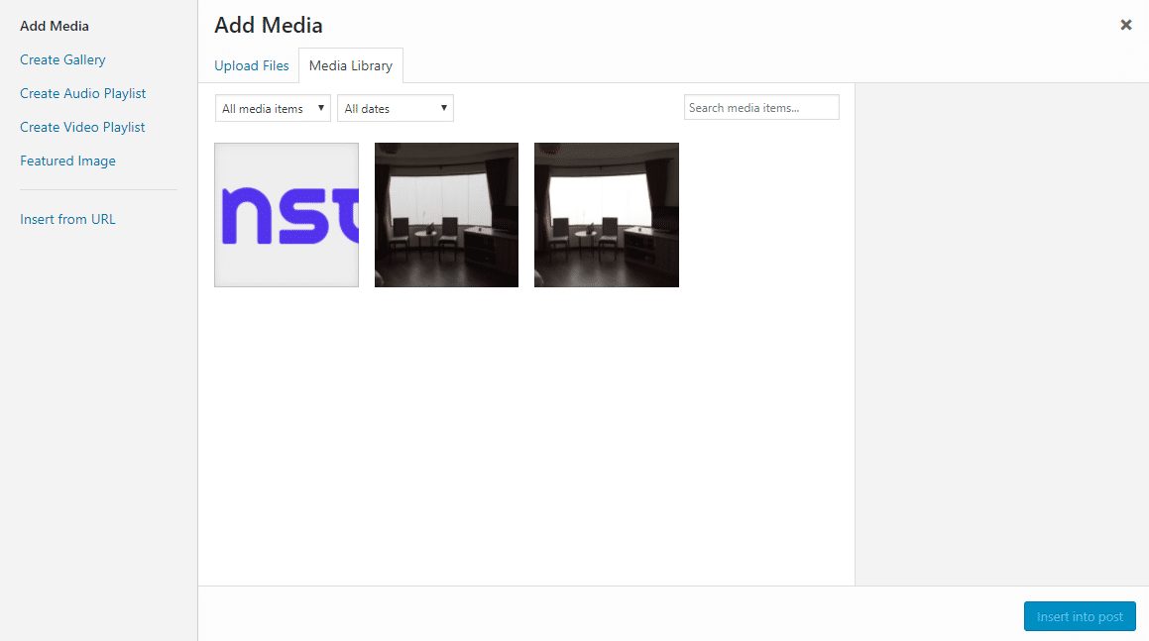

Figure 2- WordPress Media library

The content management system isn’t just a backend management interface, though. It also makes all of the content that you create show up for your visitors exactly like you want it to

# 4.WHAT MAKES UP A CONTENT MANAGEMENT SYSTEM?

On a more technical level, a content management system is made up of two core parts:

A content management application (CMA) – this is the part that allows you to actually add and manage content on your site (like you saw above)[2].

A content delivery application (CDA) – this is the backend, behind-the-scenes process that takes the content you input in the CMA, stores it properly, and makes it visible to your visitors [2].

Together, the two systems make it easy to maintain your website.

# 5.POPULAR CMS SYSTEMS

## 5.1.Wordpress

Wordpress has over 60% market share. There is about 24 million live sites that build with the helps of the Wordpress. It‘s a very popular content management system in USA, UK and Russia. The most popular websites that built with websites are: TechCrunch, The New Yorker, Beyonce, The Official Star Wars Blog, Microsoft News Center

WordPress is an open-source software and it’s free and available to download from the WordPress.org website. All you need to purchase is a domain name and WordPress hosting in order to run your website and make it available to users online[4].

WordPress is beginner-friendly; you can easily make a website, blog, or online store with this CMS. Plus, customizing your WordPress site is easy and affordable since WordPress offers thousands of free themes and plugins to choose from[4].

## 5.2.Joomla

Joomla has over 5% market share. There 1 million live websites that are built with Joomla. Joomla is very popular in United States, Russian and Germany. The most popular site are built with Joomla are : Linux, IKEA, Holiday Inn, Lipton Ice Tea.

Joomla is also a free and open-sourced software, like WordPress. Downloading Joomla is easy and many hosting providers offer 1-click installations. With Joomla, you can quickly [start a blog](https://www.isitwp.com/how-to-start-a-blog-step-by-step/), business website, community website, and more using their themes and extensions [4].

## 5.3.Drupal

Drupal has over 3% market share. There are over 581,171 live websites built with the helps or the Drupal contentent managements system. The content management system is ppopular in countries like: United States, Russia, Germany. The popular websites that built with the help of Drupal are : Tesla, Timex, Bruno Mars, Lady Gaga, Princess Cruises.

This CMS is another free and open-source software that you can use to build a website. Drupal offers themes and modules to help users [design a site](https://www.isitwp.com/effective-wordpress-theming/" \o "WordPress Theming) but they’re more difficult to find and install compared to WordPress. In addition, adding content to Drupal is simple but changing the look of your site is more a more complicated process than other content management systems [4].

# CONCLUSION

In conclusion, the content management system is a software that helps users create, manage, and modify content on a website without the need for specialized technical knowledge. The features included in content management system are : creating own website, manage post, turn file to html or pdf, tracking changes made by multiple people. The content management system is made out of two core parts : a contentment management application and a content delivery application. The popular examples of content management systems are WordPress, Joomla and Drupal.

# SOURCES

1. Kinsta Managed WordPress Hosting. 2020. *What Is A Content Management System (CMS)?*. [online] Available at: <https://kinsta.com/knowledgebase/content-management-system/> [Accessed 7 April 2020].
2. SearchContentManagement. 2020. *What Is A Content Management System (CMS)? Definition From Whatis.Com*. [online] Available at: <https://searchcontentmanagement.techtarget.com/definition/content-management-system-CMS> [Accessed 7 April 2020].
3. Magora Systems. 2019. *Content Management Application (CMA) Term Explanation, Created By Magora*. [online] Available at: <https://magora-systems.com/term-content-management-application/> [Accessed 7 April 2020].
4. Isitwp.com. 2017. [online] Available at: <https://www.isitwp.com/popular-cms-market-share/> [Accessed 7 April 2020].